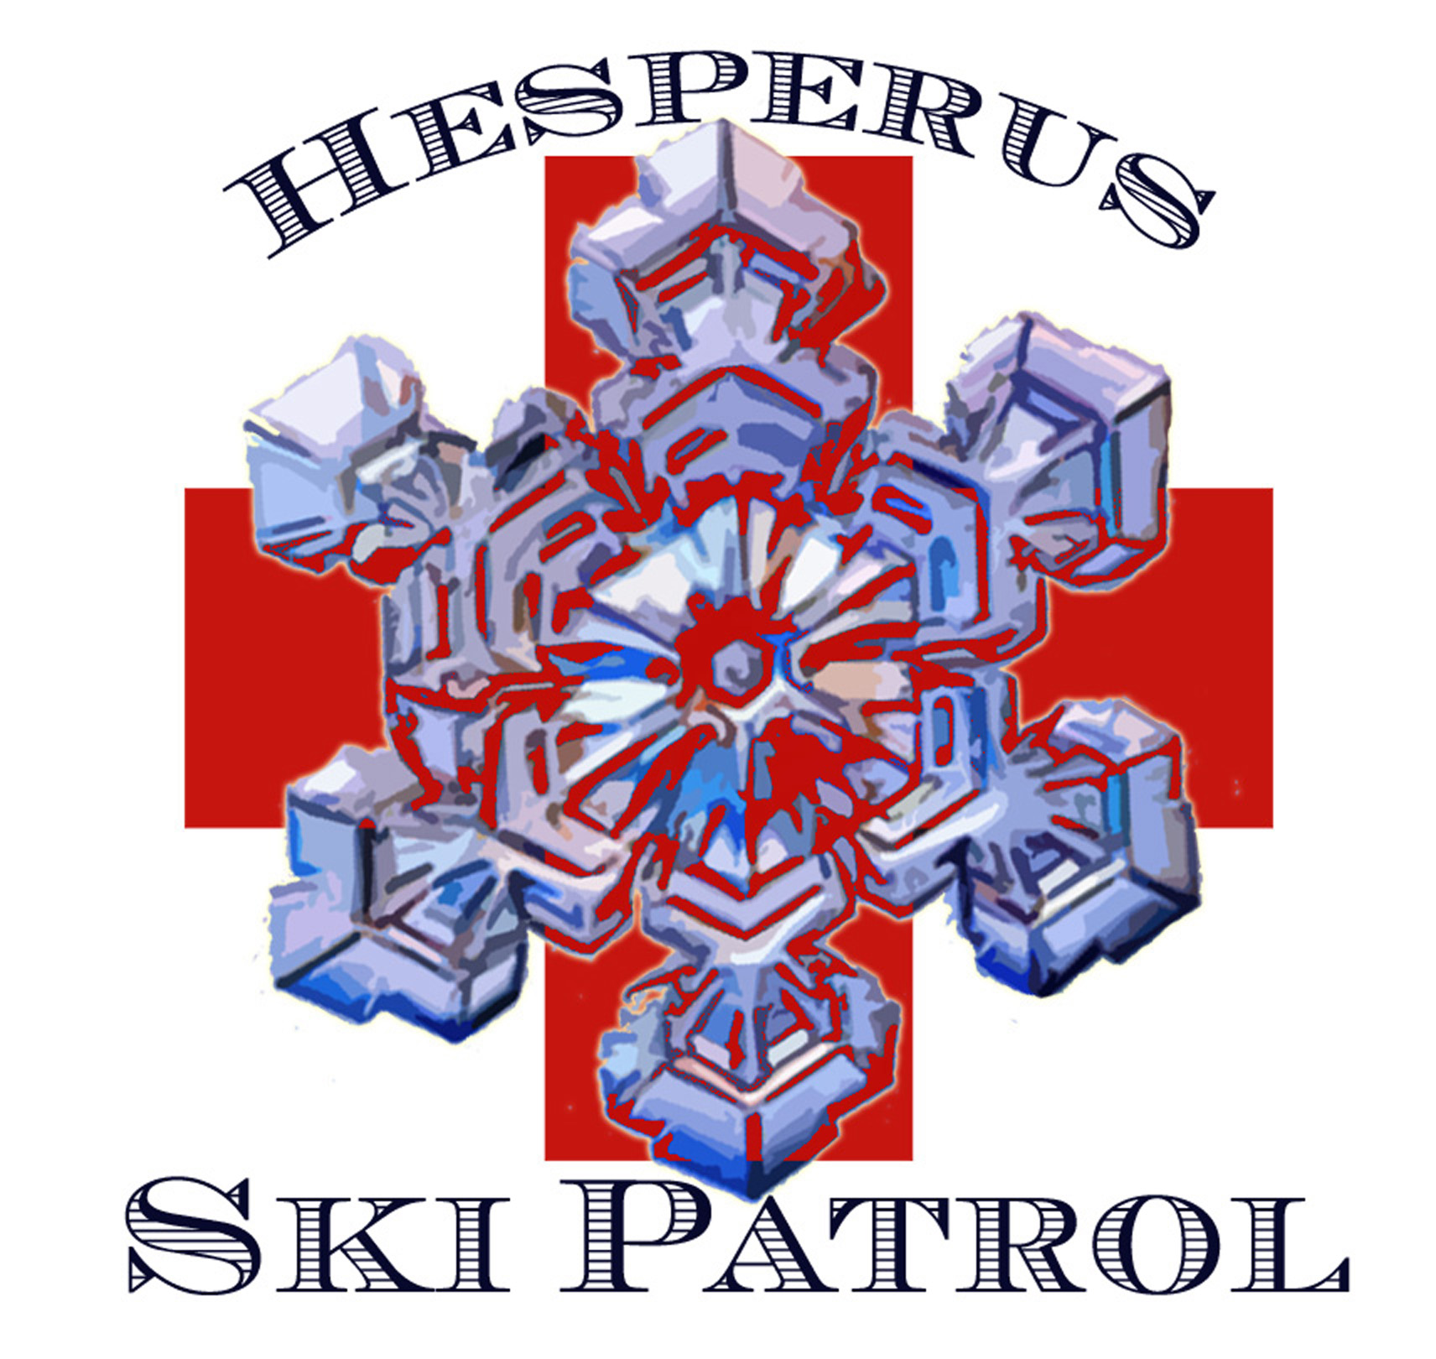

Dear Hesperus Ski Patrol Candidate,
Thank you for your interest in becoming a member of the Hesperus Ski Patrol (HSP). HSP is an all volunteer organization committed to keeping snow sports safe and enjoyable. HSP is a member of National Ski Patrol (NSP), adhering to all NSP guidelines and training recommendations. For more information on NSP, please visit their web site www.nsp.org.
HSP continually looks for dedicated volunteers. The first year requires a very high level of commitment but this will provide reward for years to come. The following is a brief outline of requirements for getting started with NSP.
- Become a member of NSP through HSP. Annual dues are $65.00
- Successfully pass an Outdoor Emergency Care (OEC) training program. The OEC class averages 120 hours of training. Persons with a medical background (EMT, RN, MD) may be able to take a shortened “bridge” class.
- Successfully pass Outdoor Emergency Transportation which includes skiing, toboggan handling, and snow machine operation.
- Complete 100 hours of volunteer time annually by participation in the ski swap, patrol shifts and meetings.
The HSP Patroller requirements are:
- Attend annual OEC refresher.
- Participate in chairlift evacuation trainings and practice.
- Complete 15 patrol shifts at Hesperus Ski Area per season.
- Participate committees and fundraisers i.e. annual Ski Swap.
A patrol position requires a strong commitment but in return for your dedication, not only will you experience the satisfaction of keeping Hesperus a safe and affordable place to ski, but you will also receive additional benefits:
- Free skiing for you and your family at Ski Hesperus.
- Discount lift tickets at participating areas.
- Access to pro deals.
- Training opportunities in OEC, Avalanche, Mountain Travel and Rescue, and multiagency live action scenarios.
- Camaraderie to last a life time.
If this sounds right for you, visit the NSP web site and read about our history and mission. For the OEC Course be prepared to pay:
$65.00 for National Ski patrol Membership (Annual Dues)
$60.00 for OEC Test
$70.00 for 5th edition OEC text
Total $190.00
Annual Dues will be paid by HSP for those who work two eight hour shifts at the Hesperus Mountain Ski Patrol Ski Swap.
For more information please contact Bruce Williams, brudijuce1@gmail.com or call 970-799-4858.

Thank you,
Bruce Williams,
Hesperus Ski Patrol Director

